W-15
YEAR 8 SCIENCE
CHEMICAL SCIENCES
REVISION - TEST 1

1. Look at p. 230 Science Quest 8 and use it to answer the following about the development of our current model of the atom. For each person, list what he or she found about the atom.

Democritus (500 BC):

Dalton (1803):

Rutherford (1911):

Bohr (1931):

Chadwick (1932):

2. Describe the structure of an atom. Draw a labelled diagram to help your explanation,
listing the component particles and their charges.

3. Define the following terms.

Element:

Compound:

Mixture:

Atomic number:

Atomic mass:

4. Which of the diagrams below represent:

(a) elements.

(b) compounds.

(c) mixtures.

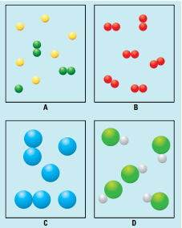

5. Classify the following substances as element, compound or mixture.

H₂O air H₂ SiO₂ cup of tea gold mercury oxide

Element | Compound | Mixture

6. Complete the following table, with either the name or symbol of the element.

ELEMENT | SYMBOL |  | ELEMENT | SYMBOL
aluminium |  |  |  | Sn
 | Na |  | copper
nitrogen |  |  |  | Si
 | B |  | fluorine
zinc |  |  |  | He
 | Pb |  | magnesium
iron |  |  |  | Ag
 | Cl |  | gold
potassium |  |  |  | Hg
 | Ne |  | bromine

7. Name the elements found in the following compounds and give the number of atoms of each.

COMPOUND | NAME AND NUMBER OF ELEMENTS PRESENT
CH₃COOH
Al₂O₃
H₂SO₄

8. Complete the following table from the information presented about the Periodic
Table.

